Dennis Motshwane

Sytnax SQL on Snowflake for BrightTV analysis

1. Total number of Distinct Users

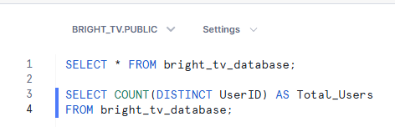

1. Top Channels by View Count

3.Factors Influencing Consumption, Days of the week

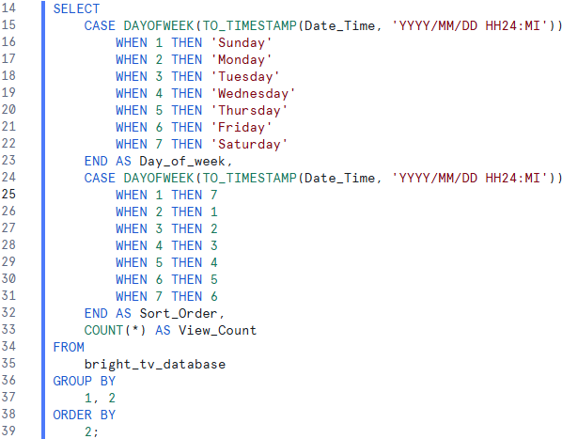

4.Factors Influencing Consumption, by Age group

5. User distribution by Province

6. User distribution by Race

6. User distribution by Gender

7. New Vs Returning Users

8.Most Popular Channels on High Days

